**Aim: Design Applications using Classes and Objects**

1. **Write a program to declare a class “staff‟ having data members as name and post.accept this data 5 staffs and display names of staff who are HOD.**

**SOURCE CODE:**

using System;

using System.Collections.Generic;

using System.Linq;

using System.Text;

namespace P2Staff

{

class staff

{

string name, post;

public void getdata()

{

Console.Write("Enter name and post:");

name = Console.ReadLine();

post = Console.ReadLine();

}

public void display()

{

Console.WriteLine(name + "\t\t" + post);

}

public string getPost()

{

return post;

}

}

class Program

{

static void Main(string[] args)

{

staff[] objStaff = new staff[5];

int i;

for (i = 0; i < 5; i++)

{

objStaff[i] = new staff();

objStaff[i].getdata();

}

Console.WriteLine("Name \t\t Post");

for (i = 0; i < 5; i++)

{

if (objStaff[i].getPost() == "HOD" || objStaff[i].getPost() == "hod")

objStaff[i].display();

}

Console.ReadLine();

}

}

}

**OUTPUT:**

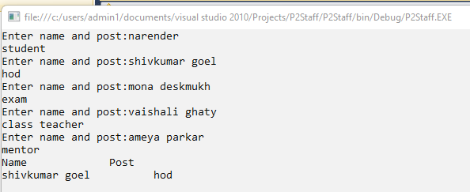

1. **Define a class “salary‟ which will contain member variables Basic, TA, DA, HRA. Write a program using Constructor with default values for DA and HRA and calculate the salary of the employee.**

**SOURCE CODE:**

using System;

using System.Collections.Generic;

using System.Linq;

using System.Text;

namespace P2Salary

{

class salary{

float bsal, hra, da, ta;

float gsal;

public void read()

{

Console.WriteLine("Enter the Base Salary");

bsal = float.Parse(Console.ReadLine());

}

public float sal()

{

hra=20*bsal/100;

da=10*bsal/100;

ta=15*bsal/100;

gsal=bsal+da+hra+ta;

return gsal;

}

}

class Program

{

static void Main(string[] args)

{

salary s = new salary();

s.read();

Console.WriteLine("The gross salary is {0}", s.sal());

Console.ReadLine();

}

}

}

**OUTPUT:**

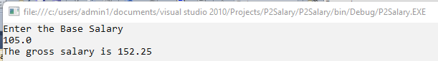

**CONCLUSION:**

From this practical, I have learned about object oriented programming concepts in c#.